Advance Computer network PCS223
Assignment-8
Suryansh Sharma 8025320099

Title: Configuring and Analysis of BGP Routing
1. Objective
- To understand the working of Border Gateway Protocol (BGP)
- To configure External BGP (eBGP) between different Autonomous Systems
- To analyse path selection using BGP attributes
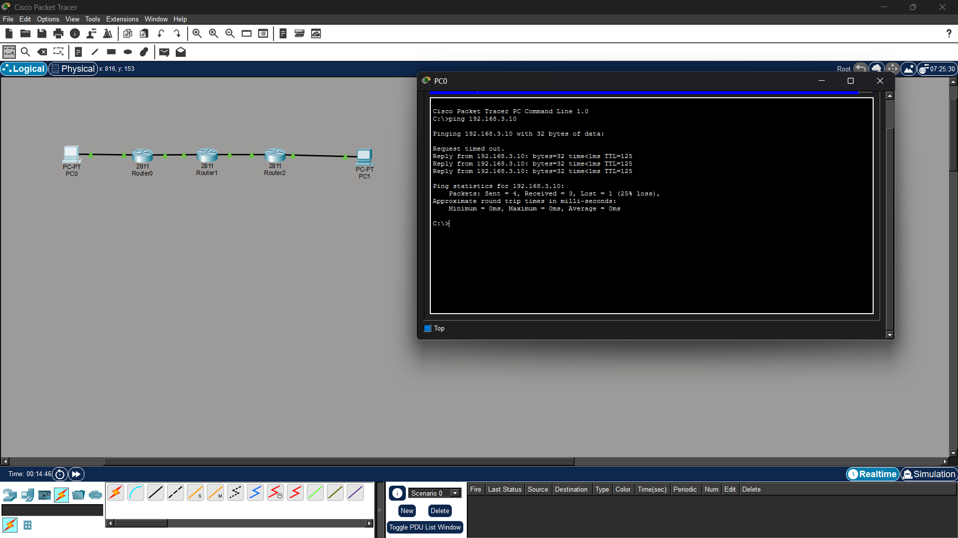

Show ip route and ip bgp
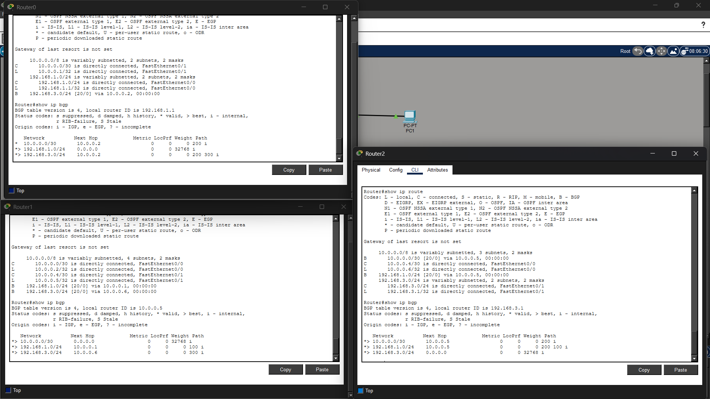
Show ip bgp summary
